**One time activity for CBDT APP**

Step 1: Install Python

[https://www.python.org/downloads](https://www.python.org/downloads/)

Step 2:

Check python is installed by opening command promt

Press Win+r

Type cmd

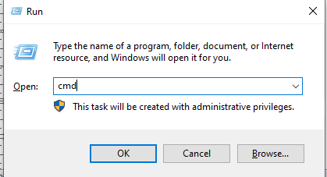

Click ok

Command prompt will open

Type python and hit Enter

You should see the screen as below

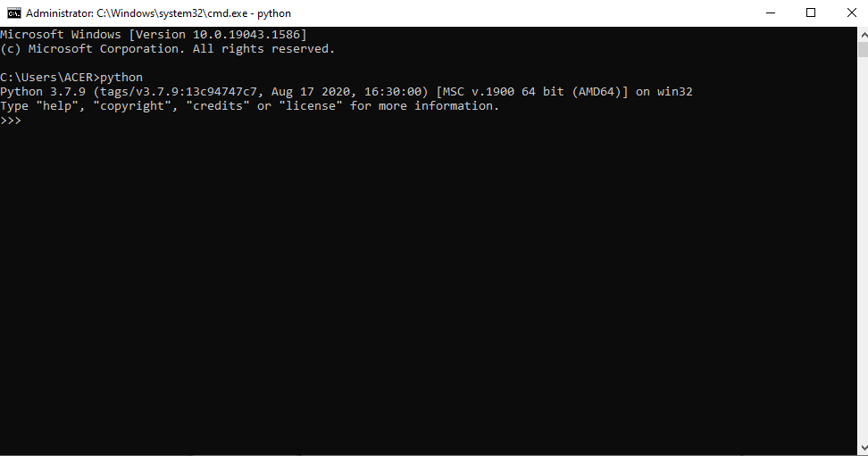

If you receive error python command not found

Please check whether python.exe is in system path

Step 3 Download CBDT app

* <https://github.com/amitcharaya/CBDTWEB>

rename folder to CBDTWEB

Step 5 Change folder to CBDTWEB

Note there may be two folders with the name CBDTWEB move to folder where manage.py file is located

Cd CBDTWEB

Step 4: Install Pip and required packages by running following commands

* python -m ensurepip –upgrade
* pip install –r requirements.txt
* Python manage.py makemigrations
* Python manage.py migrate
* Python manage.py createsuperuser

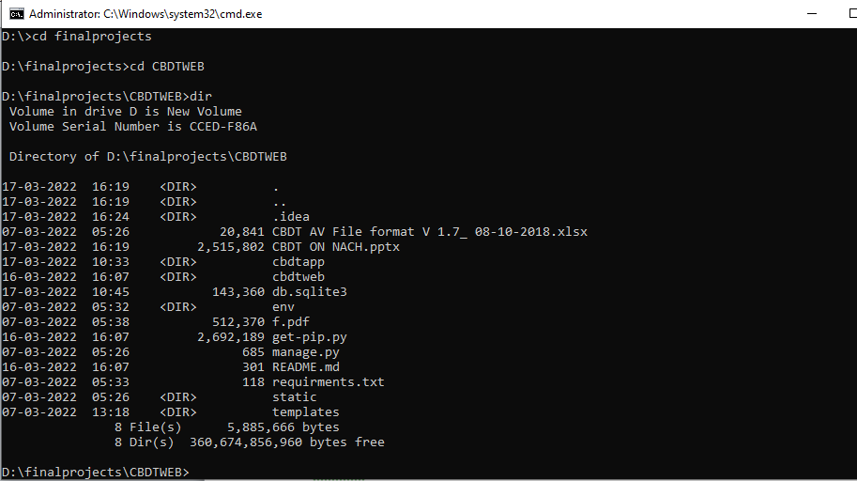

Run command

Python manage.py runserver

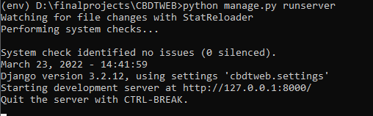

Step 6 go to admin panel and create user

Go to url 127.0.0.1:8000/admin on chrome browser

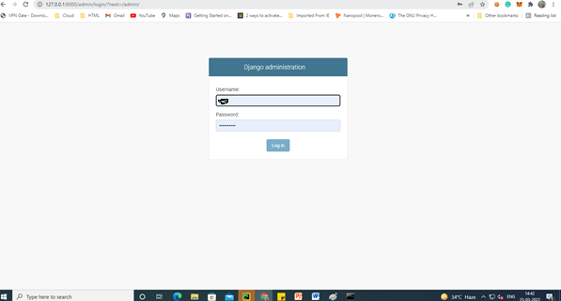

Log out

Go to url

Go to url 127.0.0.1:8000/

And access application